19.14: a) The greatest work is done along the path that bounds the largest area above the V-axis in the p- V plane (see Fig. (19.8)), which is path 1. The least work is done along path 3. 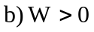 in all three cases; 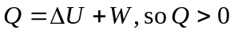 for all three, with the greatest Q for the greatest work, that along path 1. When 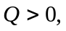heat is absorbed.

